Chapter 11, Problem 51.

For the entire circuit in Fig. 11.70, calculate:

(a) the power factor
(b) the average power delivered by the source
(c) the reactive power
(d) the apparent power
(e) the complex power

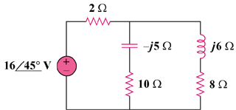

Figure 11.70
For Prob. 11.51.

